Devarapalli Hari Prasanna Nagendra
192325128
Class Test 1

Regular Expressions and Validation in JavaScript
- Student Registration Validation: Write a JavaScript program to validate a student registration form containing a full name, email address, 10-digit mobile number, date of birth in DD-MM-YYYY format, and password. The password must contain at least one uppercase letter, one lowercase letter, one digit, and one special character, with a minimum length of eight characters.
Code:

<!DOCTYPE html>
<html>
<head>
<title>Student Registration</title>
</head>
<body>
<h2>Student Registration Validation</h2>

<script>
let name = prompt("Enter full name:");
let email = prompt("Enter email address:");
let mobile = prompt("Enter 10-digit mobile number:");
let dob = prompt("Enter date of birth (DD-MM-YYYY):");
let password = prompt("Enter password:");

let errors = [];

// Validate full name
if (!/^[A-Za-z ]+$/.test(name.trim())) {
errors.push("Invalid full name.");
}

// Validate email
if (!/^[^\s@]+@[^\s@]+\.[A-Za-z]{2,}$/.test(email)) {
errors.push("Invalid email address.");
}

// Validate mobile number
if (!/^\d{10}$/.test(mobile)) {
errors.push("Mobile number must contain 10 digits.");
}

// Validate date format
if (!/^(0[1-9]|[12]\d|3[01])-(0[1-9]|1[0-2])-\d{4}$/.test(dob)) {
errors.push("Date must be in DD-MM-YYYY format.");
}

// Validate password
let passwordPattern =
/^(?=.*[A-Z])(?=.*[a-z])(?=.*\d)(?=.*[^A-Za-z0-9])(?=.{8,}).*$/;

if (!passwordPattern.test(password)) {
errors.push(
"Password must contain 8 characters, uppercase, lowercase, digit and special character."
);
}

// Display result
if (errors.length > 0) {
alert("Registration Failed:\n" + errors.join("\n"));
} else {
alert("Registration Successful!");
}
</script>
</body>
</html>

- 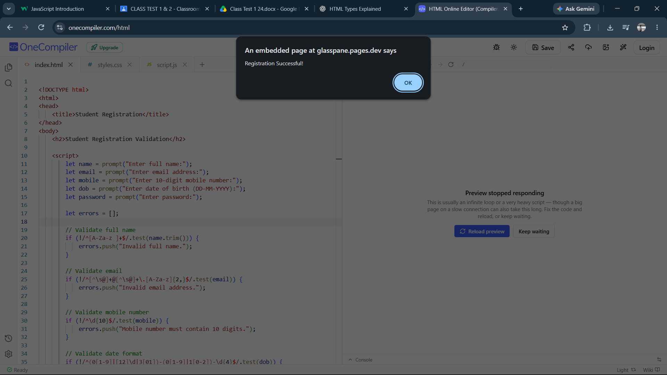
- Password Strength Validation: Write a JavaScript program to validate a password with the following rules: minimum 10 characters, at least two digits, one uppercase letter, one lowercase letter, one special character, and no whitespace. Display an appropriate error message for each failed condition.
Code:

- <!DOCTYPE html>
- <html>
- <head>
- <title>Password Strength Validation</title>
- </head>
- <body>
- <h2>Password Strength Validation</h2>

- <script>
- let password = prompt("Enter password:");
- let errors = [];

- if (password.length < 10) {
- errors.push("Password must contain at least 10 characters.");
- }

- if ((password.match(/\d/g) || []).length < 2) {
- errors.push("Password must contain at least two digits.");
- }

- if (!/[A-Z]/.test(password)) {
- errors.push("Password must contain one uppercase letter.");
- }

- if (!/[a-z]/.test(password)) {
- errors.push("Password must contain one lowercase letter.");
- }

- if (!/[^A-Za-z0-9\s]/.test(password)) {
- errors.push("Password must contain one special character.");
- }

- if (/\s/.test(password)) {
- errors.push("Password must not contain whitespace.");
- }

- if (errors.length > 0) {
- alert("Password is invalid:\n" + errors.join("\n"));
- } else {
- alert("Strong password! All rules passed.");
- }
- </script>
- </body>
- </html>
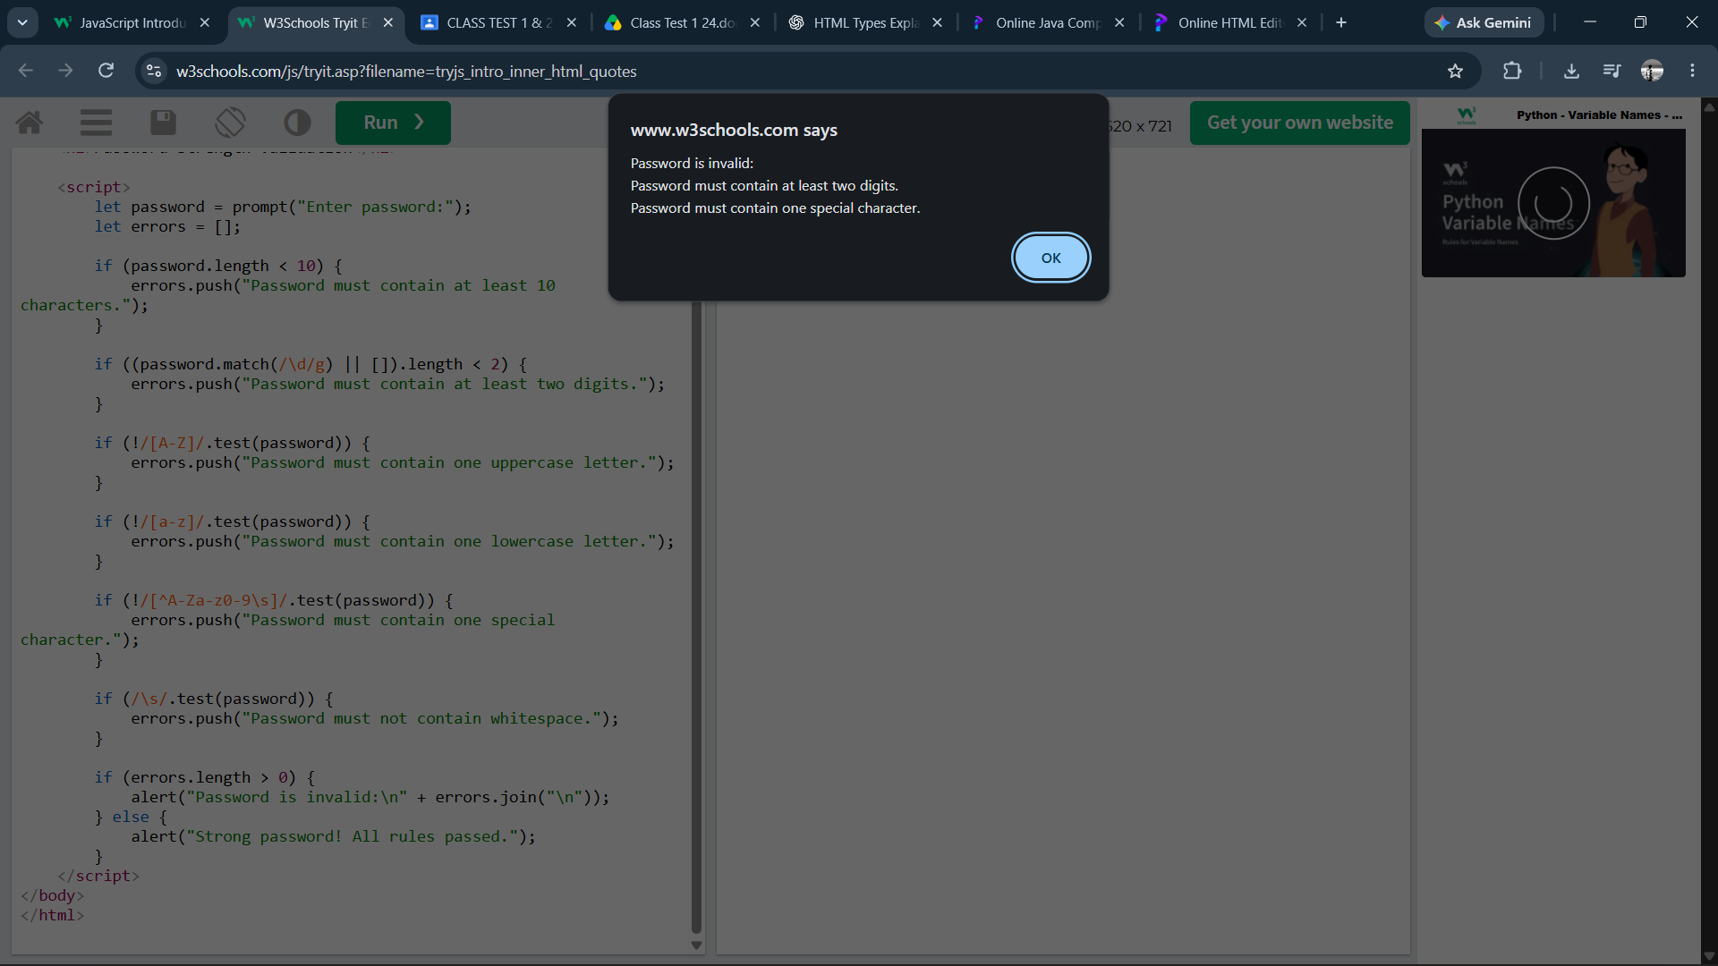
3. Email Address Validation: Write a JavaScript program to validate email addresses according to these rules: the address must contain exactly one @, a non-empty username, a domain name, and a valid-looking extension of at least two letters. Reject spaces and consecutive dots.
Code:

<!DOCTYPE html>
<html>
<head>
<title>Email Validation</title>
</head>
<body>
<h2>Email Address Validation</h2>

<script>
let email = prompt("Enter email address:");
let pattern = /^[A-Za-z0-9._%+-]+@[A-Za-z0-9-]+(?:\.[A-Za-z0-9-]+)*\.[A-Za-z]{2,}$/;

if (email && !/\s/.test(email) &&
!email.includes("..") &&
(email.match(/@/g) || []).length === 1 &&
pattern.test(email)) {
alert("Valid email address.");
} else {
alert("Invalid email address.");
}
</script>
</body>
</html>
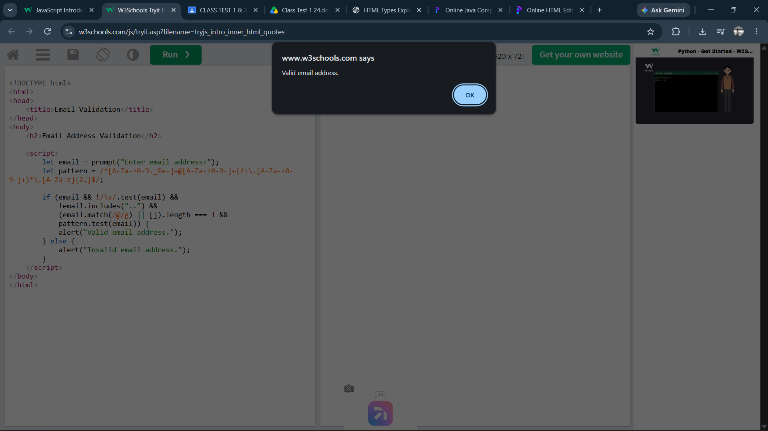

4. Username Validation: Write a JavaScript program to validate a username that must start with a letter, contain only letters, digits, and underscores, have a length of 6–15 characters, and must not end with an underscore or contain consecutive underscores.

Code:

<!DOCTYPE html>
<html>
<head>
<title>Username Validation</title>
</head>
<body>
<h2>Username Validation</h2>

<script>
let username = prompt("Enter username:");

let pattern = /^[A-Za-z][A-Za-z0-9_]{4,13}[A-Za-z0-9]$/;

if (username &&
username.length >= 6 &&
username.length <= 15 &&
pattern.test(username) &&
!username.includes("__") &&
!username.endsWith("_")) {

alert("Valid username.");
} else {
alert("Invalid username. Please follow all username rules.");
}
</script>
</body>
</html>

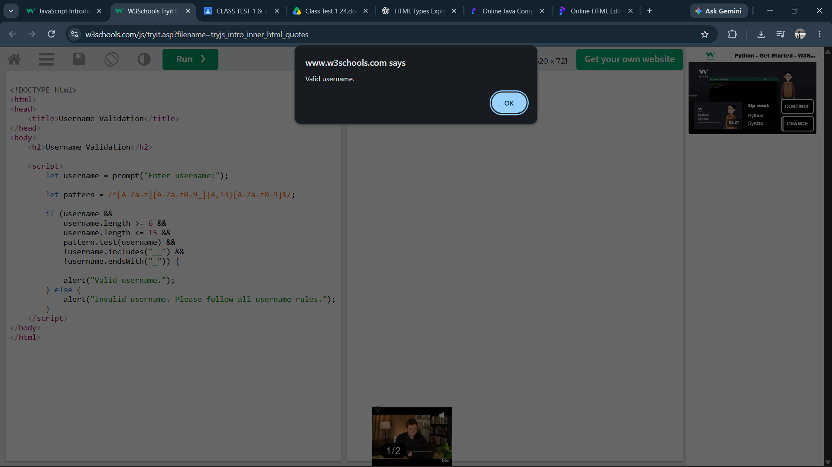
5. Extract and Analyse Data: Write a JavaScript program to extract all mobile numbers, email addresses, and dates from a paragraph using regular expressions. Display each category separately.

Code:

<!DOCTYPE html>
<html>
<head>
<title>Extract and Analyse Data</title>
</head>
<body>
<h2>Extract and Analyse Data</h2>

<script>
let paragraph = prompt("Enter a paragraph:");

// Extract 10-digit mobile numbers
let mobiles = paragraph.match(/\b[6-9]\d{9}\b/g) || [];

// Extract email addresses
let emails = paragraph.match(
/\b[A-Za-z0-9._%+-]+@[A-Za-z0-9.-]+\.[A-Za-z]{2,}\b/g
) || [];

// Extract dates in DD-MM-YYYY or DD/MM/YYYY format
let dates = paragraph.match(
/\b\d{2}[-/]\d{2}[-/]\d{4}\b/g
) || [];

alert(
"Mobile Numbers: " + (mobiles.join(", ") || "None") +
"\nEmail Addresses: " + (emails.join(", ") || "None") +
"\nDates: " + (dates.join(", ") || "None")
);
</script>
</body>
</html>

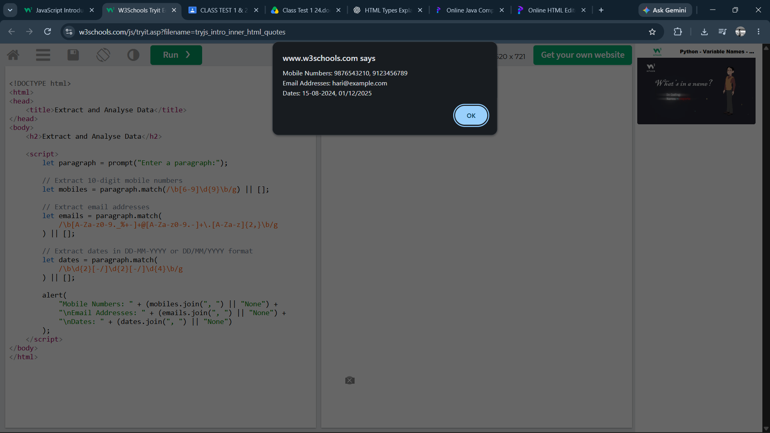

Class Test 2
6. URL Validation: Write a JavaScript program to validate URLs that begin with http:// or https://, contain a valid-looking domain name, may include a port number, and may contain a path and query parameters.

Code:

<!DOCTYPE html>
<html>
<head>
<title>URL Validation</title>
</head>
<body>
<h2>URL Validation</h2>

<script>
let url = prompt("Enter URL:");

let pattern = /^https?:\/\/(?:[A-Za-z0-9](?:[A-Za-z0-9-]{0,61}[A-Za-z0-9])?\.)+[A-Za-z]{2,}(?::\d{1,5})?(?:[/?#][^\s]*)?$/;

if (url && pattern.test(url)) {
alert("Valid URL!");
} else {
alert("Invalid URL!");
}
</script>
</body>
</html>
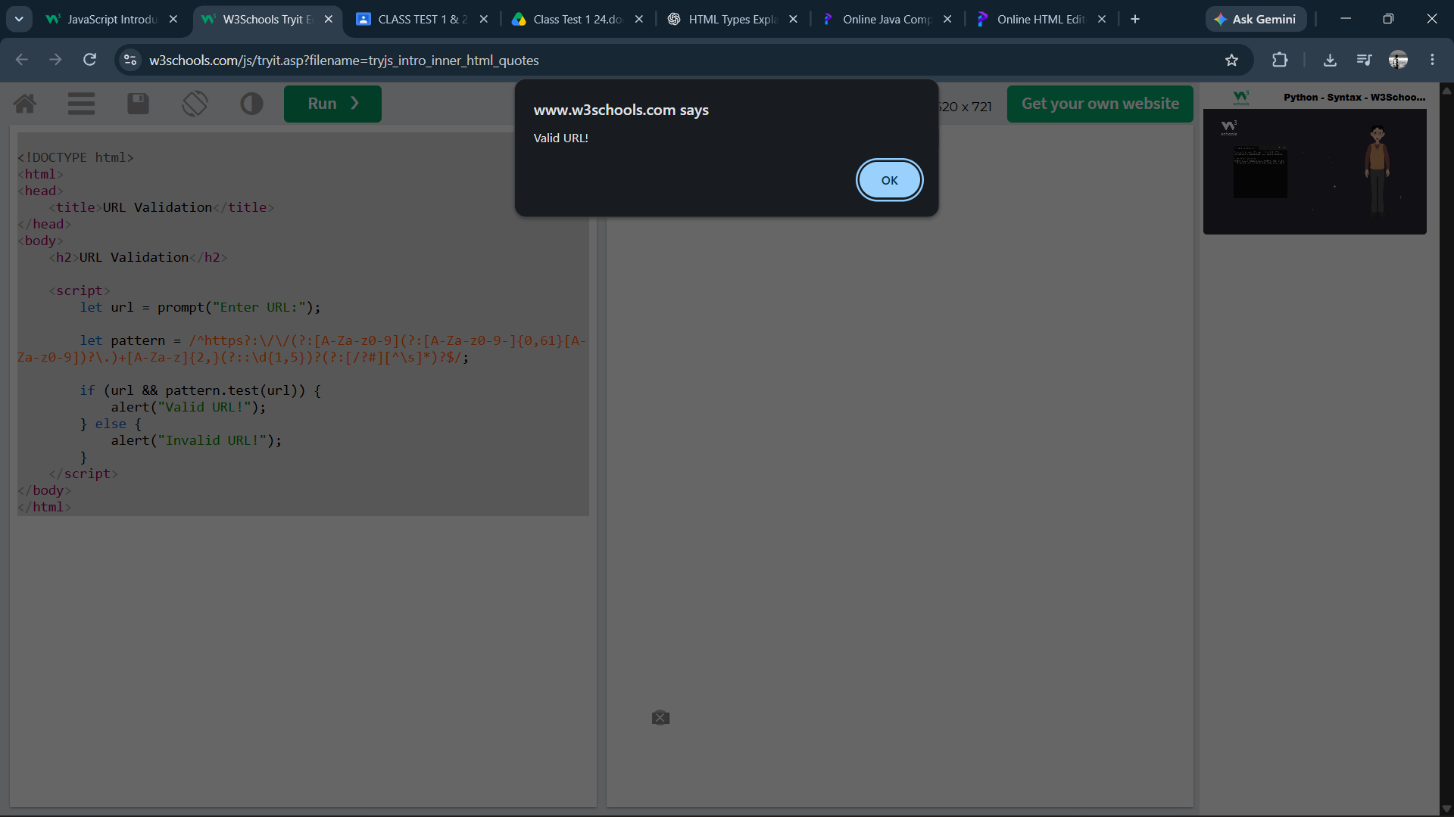
7. Repeated Word Detection: Write a JavaScript program using regular expressions to identify consecutive repeated words in a sentence, ignoring differences between uppercase and lowercase letters. For example, detect is is in the sentence "JavaScript is is easy to learn".

Code:

<!DOCTYPE html>
<html>
<head>
<title>Repeated Word Detection</title>
</head>
<body>
<h2>Repeated Word Detection</h2>

<script>
let sentence = prompt("Enter a sentence:");

let pattern = /\b([A-Za-z]+)\s+\1\b/gi;
let matches = sentence.match(pattern);

if (matches) {
alert("Repeated words found: " + matches.join(", "));
} else {
alert("No repeated words found.");
}
</script>
</body>
</html>
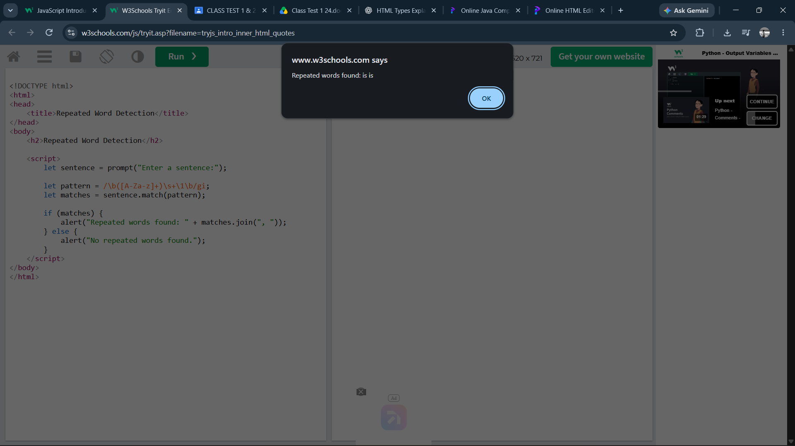

8. File Upload Validation: Write a JavaScript program to validate filenames and accept only .pdf, .docx, .jpg, and .png extensions. Reject filenames containing invalid characters, missing filenames, and unsupported extensions.

Code:

<!DOCTYPE html>
<html>
<head>
<title>File Upload Validation</title>
</head>
<body>
<h2>File Upload Validation</h2>

<script>
let filename = prompt("Enter filename:");

let allowedExtension = /\.(pdf|docx|jpg|png)$/i;
let validCharacters = /^[A-Za-z0-9_-][A-Za-z0-9_. -]*$/;

if (!filename || filename.trim() === "") {
alert("Error: Filename cannot be empty.");
}
else if (!validCharacters.test(filename)) {
alert("Error: Filename contains invalid characters.");
}
else if (filename.includes("..")) {
alert("Error: Consecutive dots are not allowed.");
}
else if (!allowedExtension.test(filename)) {
alert("Error: Only PDF, DOCX, JPG and PNG files are allowed.");
}
else {
alert("Valid filename! File extension is supported.");
}
</script>
</body>
</html>

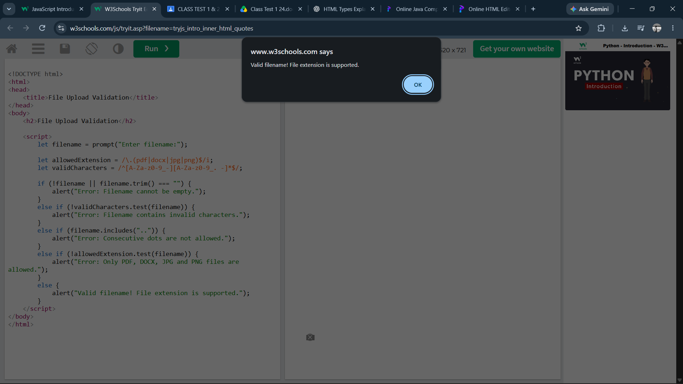
9. Log File Analysis: Write a JavaScript program to extract dates, timestamps, IP-address-shaped strings, and error codes from a server log using regular expressions. Display the extracted results in separate arrays.

Code:

<!DOCTYPE html>
<html>
<head>
<title>Log File Analysis</title>
</head>
<body>
<h2>Log File Analysis</h2>

<script>
let log = prompt("Enter server log:");

// Extract dates in YYYY-MM-DD format
let dates = log.match(/\b\d{4}-\d{2}-\d{2}\b/g) || [];

// Extract timestamps in HH:MM:SS format
let timestamps = log.match(/\b\d{2}:\d{2}:\d{2}\b/g) || [];

// Extract IP-address-shaped strings
let ips = log.match(/\b(?:\d{1,3}\.){3}\d{1,3}\b/g) || [];

// Extract error codes such as ERROR-500 or ERR404
let errors = log.match(/\b(?:ERROR|ERR)[-_ ]?\d{3,5}\b/gi) || [];

alert(
"Dates: [" + dates.join(", ") + "]\n" +
"Timestamps: [" + timestamps.join(", ") + "]\n" +
"IP Addresses: [" + ips.join(", ") + "]\n" +
"Error Codes: [" + errors.join(", ") + "]"
);
</script>
</body>
</html>

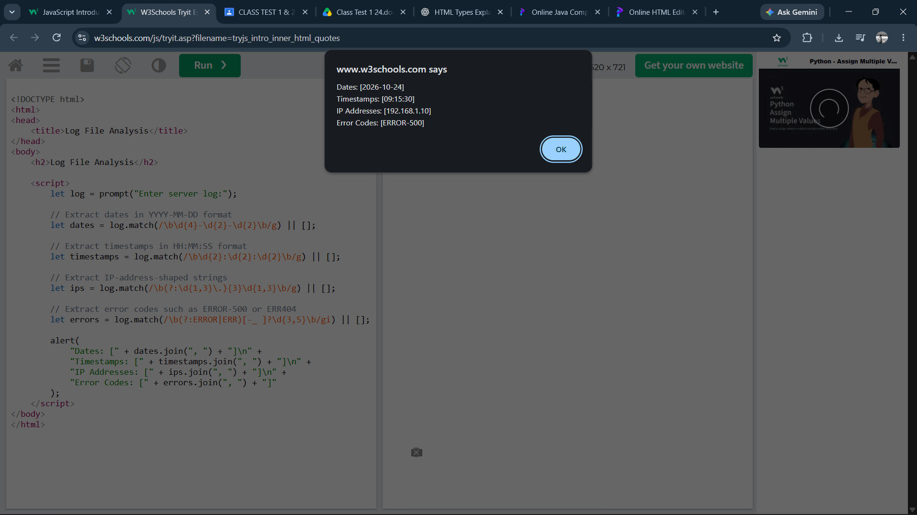
10. Comprehensive Form Validation: Develop a JavaScript form-validation program for an employee registration form containing employee ID, name, email, mobile number, date of joining, salary, and password. Apply regular expressions wherever appropriate, validate the date and salary logically, display field-specific error messages, and prevent form submission if any field is invalid.

Code:

<!DOCTYPE html>
<html>
<head>
<title>Employee Registration Validation</title>
<style>
body {
font-family: Arial, sans-serif;
margin: 30px;
}
label {
display: block;
margin-top: 12px;
}
input {
width: 300px;
padding: 8px;
}
button {
margin-top: 18px;
padding: 10px 20px;
}
#result {
margin-top: 18px;
white-space: pre-line;
}
.error {
color: red;
}
.success {
color: green;
}
</style>
</head>
<body>

<h2>Employee Registration Form</h2>

<form id="employeeForm" novalidate>
<label>Employee ID:</label>
<input type="text" id="empid">

<label>Name:</label>
<input type="text" id="name">

<label>Email:</label>
<input type="text" id="email">

<label>Mobile Number:</label>
<input type="text" id="mobile">

<label>Date of Joining (DD-MM-YYYY):</label>
<input type="text" id="doj" placeholder="25-10-2026">

<label>Salary:</label>
<input type="number" id="salary" step="0.01">

<label>Password:</label>
<input type="password" id="password">

<br>
<button type="submit">Register</button>
</form>

<div id="result"></div>

<script>
document.getElementById("employeeForm").addEventListener("submit",
function(event) {
event.preventDefault();

const getValue = id =>
document.getElementById(id).value.trim();

const errors = [];

// Employee ID: 3-12 letters, digits or hyphens
if (!/^[A-Za-z0-9-]{3,12}$/.test(getValue("empid"))) {
errors.push("Employee ID: Enter 3-12 letters, digits or hyphens.");
}

// Name validation
if (!/^[A-Za-z ]{2,}$/.test(getValue("name"))) {
errors.push("Name: Enter a valid name.");
}

// Email validation
if (!/^[^\s@]+@[^\s@]+\.[A-Za-z]{2,}$/.test(getValue("email"))) {
errors.push("Email: Enter a valid email address.");
}

// Indian mobile number validation
if (!/^[6-9]\d{9}$/.test(getValue("mobile"))) {
errors.push("Mobile: Enter a valid 10-digit mobile number.");
}

// Date validation: format and actual calendar date
const dateMatch = getValue("doj").match(
/^(0[1-9]|[12]\d|3[01])-(0[1-9]|1[0-2])-(\d{4})$/
);

let validDate = false;

if (dateMatch) {
const day = Number(dateMatch[1]);
const month = Number(dateMatch[2]);
const year = Number(dateMatch[3]);

const date = new Date(year, month - 1, day);

validDate =
date.getFullYear() === year &&
date.getMonth() === month - 1 &&
date.getDate() === day;
}

if (!validDate) {
errors.push("Date of Joining: Enter a real date in DD-MM-YYYY format.");
}

// Salary must be a finite number greater than zero
const salaryText = getValue("salary");
const salary = Number(salaryText);

if (salaryText === "" || !Number.isFinite(salary) || salary <= 0) {
errors.push("Salary: Enter an amount greater than zero.");
}

// Password validation
const passwordPattern =
/^(?=.*[A-Z])(?=.*[a-z])(?=.*\d)(?=.*[^A-Za-z0-9])(?=.{8,}).*$/;

if (!passwordPattern.test(getValue("password"))) {
errors.push("Password: Use 8+ characters with uppercase, lowercase, digit and special character.");
}

// Display errors or success
const result = document.getElementById("result");

if (errors.length > 0) {
result.className = "error";
result.textContent =
"Please correct these errors:\n- " + errors.join("\n- ");
} else {
result.className = "success";
result.textContent = "Employee registered successfully!";
}
});
</script>

</body>
</html>
